Grade 7 Accelerated · Unit 4  Unit 4 Review  Solving Problems with Rational Numbers | Name______________________  Date______________________  Period____________________

Show your work. Circle your final answer.
HOW TO USE THIS. This review covers every learning target from the unit — more than the assessment does. Work it in parts. If you miss two or more in a part, that part is where to spend your study time. The reference sheet has everything you need for each part.
PART A. Adding and Subtracting in Scientific Notation Lesson 1 · 6 questions
1. 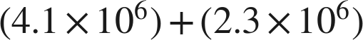

2.

3. 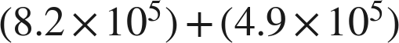

4. 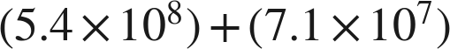

5.

6. Lena writes . Name her two mistakes and give the correct sum.

PART B. Multiplying and Dividing in Scientific Notation Lessons 2–3 · 6 questions
7. 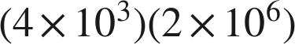

8. 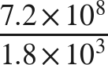

9. 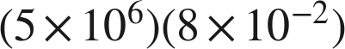

10. 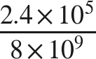

11. 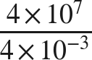

12. A laser emits  photons each second. How many does it emit in 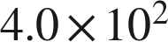 seconds?

PART C. Real-World Problems and Significant Digits Lesson 4 · 6 questions
13. How many significant digits are in each measurement? 6,040 g · 0.00920 m · 45.00 s

14. A rectangular panel measures 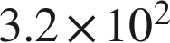 mm by 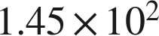 mm. Find its area, with the correct number of significant digits.

15. A train travels 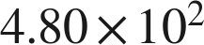 km in 6.0 hours. Find its average speed, with the correct number of significant digits.

16. Two lengths are measured: 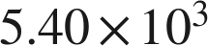 mm and 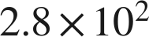 mm. Find their sum, with the correct precision.

17. Two masses are measured: 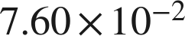 g and 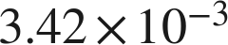 g. Find their difference, with the correct precision.

18. Micah adds two measured lengths, 2,340 m and 6.8 m, and says the sum must be written with two significant digits, as 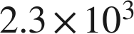 m. Is he right? Explain, and give the correct sum.

PART D. Evaluating Expressions with Radicals Lesson 5 · 7 questions
19. 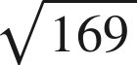

20. 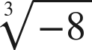

21. 

22. 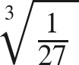

23. 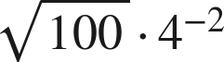

24. 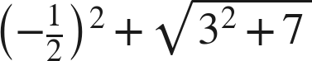

25. Kai says that 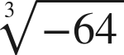 is not a real number. Is he right? Explain.

PART E. The Order of Operations Lesson 6 · 7 questions
26. 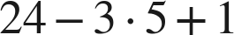

27. 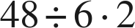

28. 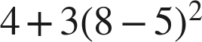

29. 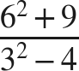

30. 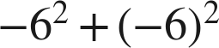

31. 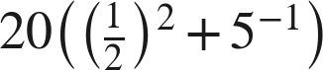

32. Which expression is equivalent in value to 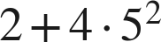 ?
○ A. 
○ B. 
○ C. 
○ D. 

PART F. Real-World Problems and the Order of Operations Lessons 7–8 · 5 questions
33. Evaluate 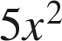 when 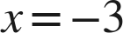.

34. Kinetic energy is . Find  when  kg and  m/s.

35. A gym charges 30 dollars to join plus 12 dollars for each of 4 months. A second gym charges 30 dollars for each of 12 months plus 4 dollars to join. Find both totals.

36. Every part below is about a square patio of side 15 feet, sealed at 2.20 dollars a square foot with a flat 60 dollars for delivery.
a. What is the area of the patio?

b. Write an expression for the total cost.

c. Find the total cost.

d. A second square patio, at the same rate and the same flat fee, costs 940 dollars. What is its side?

37. A square court of side 18 feet is resurfaced at 3.50 dollars a square foot, with a flat 140 dollars for the equipment. Which expression gives the total cost?
○ A. 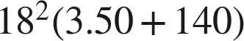
○ B. 
○ C. 
○ D. 